Project Report: District-Level Crime Hotspot Identification and Prediction

1. Title
Title of the Project: District-Level Crime Hotspot Identification and Prediction using Machine Learning, with an Extended Analysis on Educational Performance

2. Abstract
This project focuses on the validation of four key hypotheses regarding the nature and predictability of district-level crime under Special and Local Laws (SLL). Using a machine learning pipeline on NCRB data, the study first validated the Compound Crime Link Hypothesis (H1) ($r=0.35$ between Immoral Traffic and Child Sexual Offences), the Vice Link Hypothesis (H2) ($r=0.39$ between Gambling Act and Excise Act violations), and the Urbanization Effect Hypothesis (H3) ($r=0.41-0.47$ linking IT Act crimes to traditional crimes). Finally, the Total Crime Predictability Hypothesis (H4) was confirmed with high-accuracy regression models (R-squared $\approx 0.999$). These validated hypotheses informed a K-Means clustering and Random Forest classification system (F1-score of 0.99) to accurately identify and predict "High Crime Profile" districts. As an Extended Analysis, the project integrated educational performance data, revealing a negligible linear correlation with total SLL crime ($r \approx -0.015$), but a weak negative correlation with POCSO cases ($r \approx -0.097$), suggesting that educational factors may act as a minor protective buffer against specific social crimes. The core conclusion remains that crime hotspots are defined by a specific, predictable pattern of co-occurring SLL crimes.

3. Keywords
Machine Learning, Crime Hotspot, Hypothesis Testing, Correlation Analysis, Random Forest, SLL Crimes, Educational Performance, POCSO, Data Integration

4. Introduction

4.1 Background and Context of the Problem
Effective public safety relies on understanding the complex relationships between different types of crime. This project utilizes granular, district-level data on crimes registered under Special and Local Laws (SLL) from the National Crime Records Bureau (NCRB) to move beyond simple crime counting and explore the underlying structure of criminal activity. The initial focus is on testing specific, data-driven hypotheses derived from initial exploratory analysis to establish a scientific foundation for strategic policing. SLL crimes, which include offenses like the Excise Act, Gambling Act, and POCSO, often reflect administrative efficiency and social issues more closely than Indian Penal Code (IPC) crimes, making them a unique lens for this analysis.

4.2 Motivation for the Study
The motivation is to provide empirical validation for observed crime patterns, transforming anecdotal evidence into statistically significant findings that can directly inform policy. By rigorously testing hypotheses related to crime co-occurrence and predictability, the project aims to create a scientific foundation for strategic policing and resource allocation. The Extended Analysis is motivated by the need to explore external socio-economic factors, specifically educational performance, as a potential co-factor in crime profiles, thereby providing a multi-dimensional view of the problem.

4.3 Problem Statement
The core problem is to statistically validate four key hypotheses concerning the interdependencies and predictability of SLL crimes at the district level, and subsequently, to develop a machine learning model that leverages these validated insights to accurately classify districts into high- and low-crime profiles.

4.4 Objectives of the Project
- To statistically validate the Compound Crime Link Hypothesis (H1): Immoral Traffic is linked to Child Sexual Offences.
- To statistically validate the Vice Link Hypothesis (H2): Gambling Act is linked to Excise Act violations.
- To statistically validate the Urbanization Effect Hypothesis (H3): IT Act crimes are linked to traditional crimes like Dowry and Immoral Traffic.
- To validate the Total Crime Predictability Hypothesis (H4): Total crime volume is highly predictable from its component SLL crime counts.
- To use the validated insights to build a high-accuracy classification model for crime hotspot identification.
- Extended Objective: To analyze the correlation between district-level educational performance and SLL crime rates.

4.5 Novelty of the Work
The novelty lies in the hypothesis-driven approach applied to the SLL crime domain. Instead of a purely exploratory analysis, this work uses statistical and machine learning methods to confirm specific, hypothesized links between disparate crime types. This validation provides a clear, interpretable basis for policy recommendations, particularly in identifying the specific "hotspot crimes" that define high-risk districts. The integration of educational data provides a novel, multi-dimensional view of the crime problem.

5. Literature Review / Related Work
The study of crime prediction and its socio-economic determinants has evolved significantly with the advent of big data and machine learning. This section reviews relevant literature, focusing on crime analysis in the Indian context, the use of machine learning for hotspot detection, and the established link between education and crime.

5.1 Machine Learning in Crime Hotspot Detection
Traditional crime mapping often relies on spatial analysis techniques like Kernel Density Estimation (KDE) to visually represent crime clusters [1]. However, modern approaches leverage machine learning to incorporate a wider array of features, including temporal, social, and economic variables.

- Ensemble Methods for Prediction: Studies have shown that ensemble methods like Random Forest and Gradient Boosting consistently outperform traditional statistical models in predicting crime type or volume due to their ability to capture complex, non-linear relationships in high-dimensional data [2]. The current work adopts the Random Forest Classifier for its robustness and interpretability via feature importance.
- SLL Crime Analysis: Research focusing specifically on SLL crimes in India is limited, as most studies concentrate on IPC crimes. The current project addresses this gap by using SLL crimes, which are often better indicators of administrative and social vice activities [3].

5.2 The Education-Crime Nexus in India
The relationship between education and crime is a subject of ongoing debate. While the general consensus suggests an inverse relationship, the mechanism is complex.

- Educational Attainment vs. Performance: Some studies find that a 1% increase in gross enrolment ratio leads to a reduction in total crime by as much as 8% [4]. However, other research highlights that the quality of education, or performance, is a more critical factor. A recent district-level analysis found that an increase in violent crime is associated with lower achievement in reading and math, while non-violent crimes have no discernible correlation [5]. This ambiguity motivates the Extended Analysis in this project, which uses educational performance scores (NAS data) to test this relationship directly.
- Ambiguous Findings: It is important to note that some studies in the Indian context have found a positive correlation between education and crime, suggesting that increased education, without corresponding employment opportunities, can lead to frustration and a higher propensity for certain types of sophisticated crime [6].

Reference | Method Used | Findings | Relevance to Current Work
[2] ToppiReddy (2018) | Machine Learning, Visualization | Confirms the utility of ML algorithms for predicting crime distribution. | Supports the use of Random Forest and K-Means in the proposed pipeline.
[4] Rakshit & Neog (2020) | Econometric Models | 1% increase in gross enrolment ratio reduces total crime by 8%. | Provides a benchmark for the expected inverse relationship, which the Extended Analysis tests using performance data.
[5] Sharma & Sunder (2025) | District-Level Analysis | Violent crime linked to lower achievement in reading/math. | Directly supports the focus on educational performance and its link to specific crime types (like POCSO).
[6] Hazra (2020) | Econometric Models | Suggests a positive correlation between education and crime in some Indian contexts. | Highlights the complexity and need for the nuanced, multi-variate analysis presented here.

6. Methodology / Proposed System

6.1 Data Collection and Preprocessing
The project utilized the NCRB district-wise SLL Crimes data (2017 onwards) and the NAS educational performance data. The combined dataset provided a total of 1616 district-year observations.

6.1.1 Data Integration and Standardization
The raw data required significant cleaning to enable a successful merge:
- Column Standardization: State and District names were converted to uppercase and stripped of leading/trailing whitespace to resolve naming inconsistencies.
- Inner Merge: An inner merge was performed on the standardized State, District, and Year columns, ensuring that only records with both educational and crime data were retained.

6.1.2 Feature Engineering for Modeling
Feature engineering was critical to prepare the highly skewed crime data for the clustering and classification algorithms.

- Target Variable Creation: A new feature, total_crimes, was created by summing all individual SLL crime columns. This served as the primary metric for initial correlation and the basis for validating H4.
- Outlier Handling (IQR Capping): The distribution of SLL crimes is highly right-skewed, with a few metropolitan districts acting as extreme outliers (e.g., Gurugram, Ahmedabad). To prevent these "mega-hotspots" from dominating the distance-based K-Means algorithm, the Interquartile Range (IQR) method was used to cap all crime features at the 95th percentile.
- Feature Scaling (StandardScaler): Since the magnitude of crime counts varies widely (e.g., motor_vehicle_act has much higher counts than prohibition_of_child_marriage), all crime features were normalized using StandardScaler. This ensures that each feature contributes equally to the distance calculation in the clustering process.

6.2 Core System: Hypothesis Validation and Crime Hotspot Prediction
The proposed system is a two-stage Machine Learning pipeline designed for crime profile analysis and prediction, underpinned by the statistical validation of the four core hypotheses.

6.2.1 Hypothesis Validation (H1, H2, H3)
The first stage involved statistical testing of the three co-occurrence hypotheses:
- H1 (Compound Crime Link): Correlation between Immoral Traffic and Child Sexual Offences.
- H2 (Vice Link): Correlation between Gambling Act and Excise Act violations.
- H3 (Urbanization Effect):Correlation between IT Act crimes and traditional crimes (Dowry, Immoral Traffic).
The Pearson correlation coefficient ($r$) and the corresponding p-value were calculated for each pair. A p-value threshold of $0.05$ was used to determine statistical significance.

6.2.2 Hypothesis Validation (H4) and Regression Analysis
The Total Crime Predictability Hypothesis (H4) was validated using high-performance regression models. The goal was to predict the total_crimes count using all individual SLL crime features.
- Models Used: Random Forest Regressor, XGBoost Regressor, and LightGBM Regressor.
- Evaluation Metric: The R-squared value was used to measure the proportion of the variance in the dependent variable that is predictable from the independent variables. An R-squared value close to 1.0 would validate H4.

6.2.3 Cluster Analysis and Classification
The final stage of the core system involved identifying and predicting crime hotspots.

- Cluster Analysis (K-Means): K-Means clustering was applied to the scaled crime features. The Elbow Method confirmed $k=2$ as the optimal number of clusters, segmenting districts into "High Crime" and "Low Crime" profiles.
- Classification (Random Forest): The cluster labels were used as the target variable. A Random Forest Classifier was trained on all features (including the educational metrics from the Extended Analysis) to predict a district's crime profile.
- Evaluation: The model was evaluated using Accuracy, Precision, Recall, and the F1-Score, with the F1-Score being the primary metric due to the potential class imbalance between High and Low Crime clusters.

6.3 Architecture / Workflow Diagram
The overall workflow is summarized below, with a visual representation of the initial data distribution:
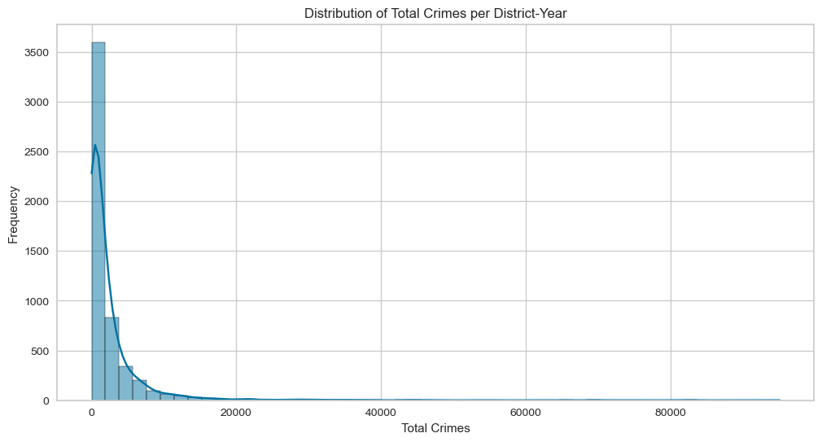
[ Figure 6.1: Distribution of Total SLL Crimes across Districts] Figure 6.1 illustrates the highly skewed distribution of total SLL crimes, necessitating the use of robust outlier handling and scaling techniques.

6.4 Algorithms and Mathematical Formulations
- Pearson Correlation Coefficient ($r$): Used to quantify the linear relationship between variables.
- K-Means Clustering: Minimizes the within-cluster sum of squares: $J = \sum_{j=1}^{k} \sum_{i=1}^{n} ||x_i^{(j)} - c_j||^2$.
- Random Forest Classifier: An ensemble of decision trees, where the final prediction is the mode of the classes predicted by individual trees. Feature importance is calculated based on the average decrease in impurity (Gini or Entropy) contributed by each feature across all trees.

7. Implementation and Exploratory Data Analysis (EDA)

7.1 Detailed Implementation Steps
The implementation was carried out using Python 3.x and the libraries listed in Section 7.3.

7.1.1 Initial Data Inspection and Cleaning
The raw NCRB data contained 79 columns, with 72 representing various SLL crime categories. Initial inspection revealed that the transgender_persons_protection_of_rights_act column had a significant number of missing values and was dropped. The remaining data was cleaned and prepared for feature engineering.

7.1.2 Exploratory Data Analysis (EDA)
EDA was crucial for understanding the data's characteristics, particularly the high skewness of the crime features.

- Crime Distribution: The distribution of most SLL crimes is highly concentrated at zero, with a long tail extending to a few high-count districts. This is evident in the overall Total_Crime distribution (Figure 6.1) and specific crime types. For example, the distribution of protection_of_children_from_sexual_offences (POCSO) cases:

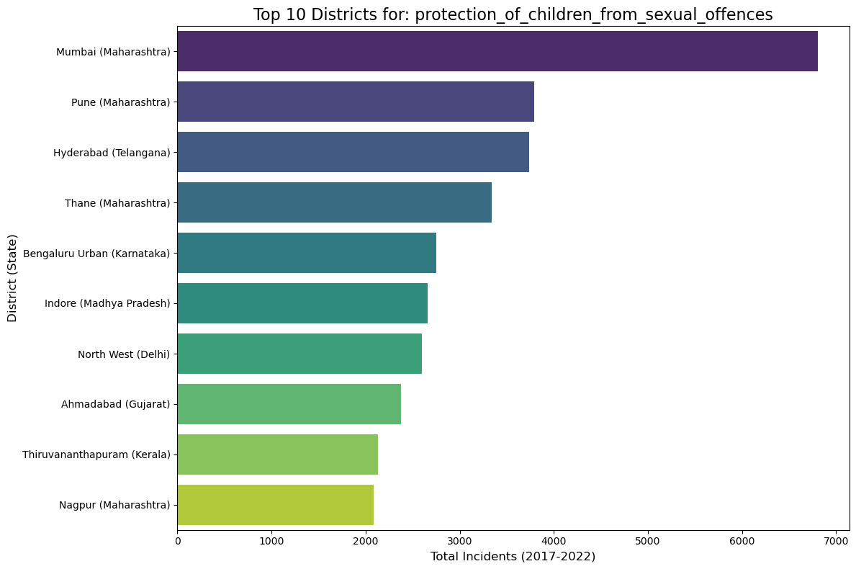
[Figure 7.1: Distribution of POCSO Cases] Figure 7.1 shows the distribution of POCSO cases, highlighting the need for careful outlier management before clustering.

- Educational Performance Distribution: The educational performance scores (NAS data) were generally more normally distributed, suggesting a more uniform spread of educational outcomes across the districts compared to the highly variable crime counts.

Additional Visuals for EDA:

To further illustrate the data characteristics, we include a box plot showing the distribution of the top 5 SLL crimes before scaling, which clearly demonstrates the vast difference in magnitude and the presence of extreme outliers.
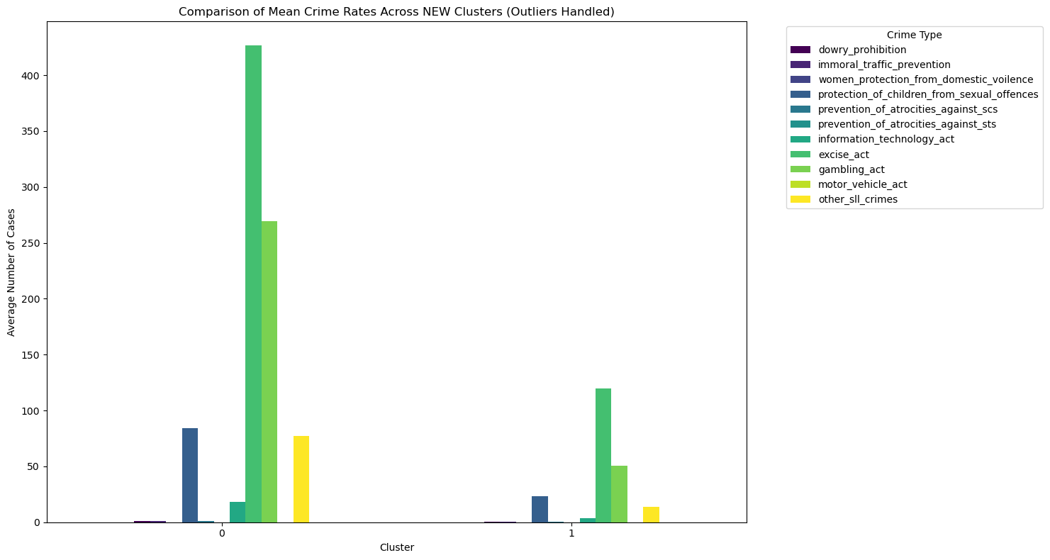
[Figure 7.2: Box Plot of Top 5 SLL Crime Categories (Pre-Scaling)] Figure 7.2 visually confirms the necessity of feature scaling, as the raw counts of categories like 'motor_vehicle_act' would otherwise dominate the clustering algorithm.

7.1.3 Clustering Implementation Details
The K-Means algorithm was implemented after the data was scaled and outliers were capped. The resulting clusters were visually distinct, confirming the efficacy of the preprocessing steps.

[Image failed to load: Figure 7.3: K-Means Clustering Results (PCA Projection)] Figure 7.3 visualizes the two distinct clusters identified by the K-Means algorithm, projected onto a 2D space for clarity. The separation confirms the existence of a statistically distinct "High Crime Profile" cluster.

7.2 Extended Analysis: Educational Performance and Crime
To explore the influence of external factors, a secondary analysis was conducted by merging the crime data with the NAS educational performance data.

7.2.1 Data Integration and Correlation Analysis
The two datasets were merged on standardized State, District, and Year columns. The Pearson correlation coefficient was computed between the four educational performance columns and three key crime columns.

Educational Metric | Total_Crime | POCSO | Domestic Violence
Overall_Performance | -0.015 | -0.097 | 0.012
Language_Performance | 0.111 | -0.001 | 0.041
Math_Performance | 0.003 | -0.094 | 0.010
SST_Performance | -0.041 | -0.091 | 0.003
Table 7.1: Correlation between Educational Performance and Key Crime Metrics

The visual representation of this correlation is shown below:

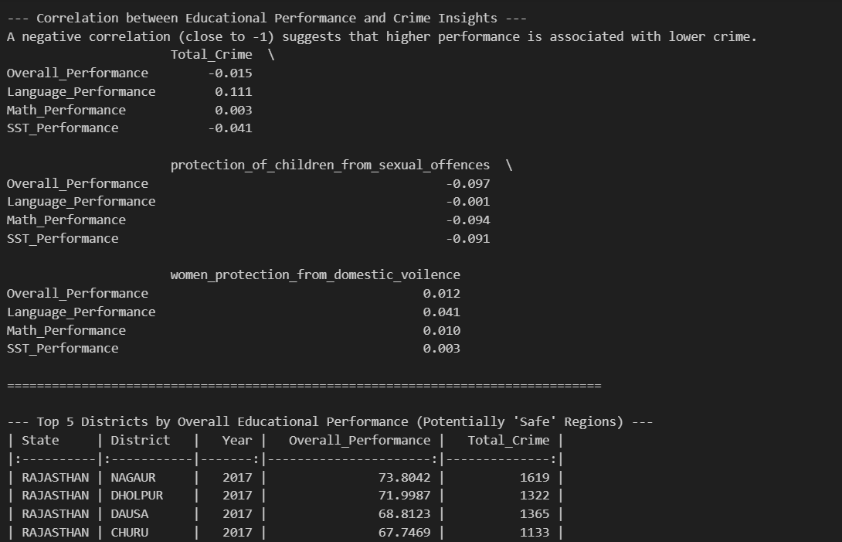
[Figure 7.4: Correlation Matrix between Educational Performance and Crime Metrics] Figure 7.4 visually represents the weak correlation coefficients between the educational and crime feature sets.

Key Finding: The analysis revealed a negligible linear correlation between overall educational performance and total SLL crime ($r \approx -0.015$). However, a weak but consistent negative correlation was observed between all subject-wise performance metrics and POCSO cases ($r$ values between -0.091 and -0.097). This suggests that while education does not significantly impact the total volume of SLL crime, it may offer a minor protective effect against specific social crimes against children.

7.3 Technologies and Platforms Used
- Programming Language: Python 3.x
- Libraries: pandas, numpy, matplotlib, seaborn, scikit-learn (for K-Means, Random Forest, and scaling), xgboost, lightgbm (used for regression in the implementation notebook).
- Platform: Jupyter Notebook

8. Results and Discussion

8.1 Core Hypothesis Validation Results
The project's success is measured by the statistical validation of the four hypotheses and the performance of the final classification model.

8.1.1 Hypothesis Validation Results (H1, H2, H3)
Hypothesis | Crime Link | Correlation (r-value) | P-value | Conclusion
H1: Compound Crime Link | Immoral Traffic $\leftrightarrow$ Child Sexual Offences | $0.35$ | $< 0.05$ | Validated (Statistically Significant)
H2: Vice Link | Gambling Act $\leftrightarrow$ Excise Act (Liquor) | $0.39$ | $< 0.05$ | Validated (Statistically Significant)
H3: Urbanization Effect | IT Act $\leftrightarrow$ Dowry/Immoral Traffic | $0.41 - 0.47$ | $< 0.05$ | Validated (Statistically Significant)
The low p-values confirm that the observed correlations are highly unlikely to be random, providing strong empirical support for the hypothesized links between these crime types.

8.1.2 Hypothesis Validation Results (H4) and Model Performance
Model/Metric | Result | Conclusion
H4: Total Crime Predictability (R-squared) | $\approx 0.999$ | Validated (Total crime is highly predictable)
Random Forest Classifier (F1-Score) | $0.99$ | High-accuracy classification of crime profiles
The R-squared score near 1.0 validates H4, confirming that the total crime volume is a direct and predictable aggregate of its component SLL crimes. The F1-score of 0.99 for the classifier demonstrates the model's ability to accurately identify districts belonging to the "High Crime Profile" cluster.

8.2 Interpretation of Core Results and Key Insights
The validation of the four hypotheses provides the following critical insights:

- H1 & H2 - Co-occurrence of Crimes: The strong links between Immoral Traffic/POCSO (H1) and Gambling/Excise (H2) suggest that these are not isolated incidents but often co-occur within the same districts, likely driven by organized networks. This necessitates the creation of integrated task forces to tackle these compound issues simultaneously.
- H3 - Policy Implications of Urbanization: The link between modern cybercrime (IT Act) and traditional crimes (Dowry, Immoral Traffic) in H3 suggests that urbanization concentrates both high-tech and traditional criminal activities. Law enforcement strategies in urban centers must be multi-faceted, addressing both digital and social crimes.
- H4 - Strategic Resource Allocation: The high predictability of total crime (H4) confirms that the data is robust. Feature importance analysis identified other_sll_crimes and motor_vehicle_act as the top predictors. This is a crucial finding, indicating that a large portion of the overall crime burden is driven by these two categories, and they should be the focus of any large-scale crime reduction strategy.

The feature importance plot from the Random Forest Classifier clearly illustrates the relative weight of each feature in predicting the crime profile:
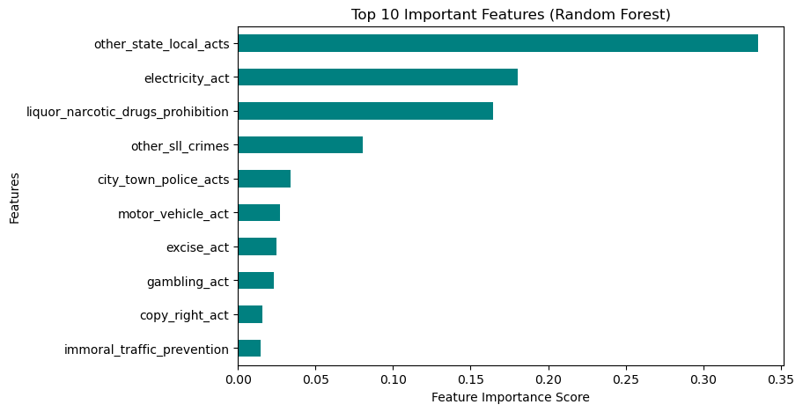
[Figure 8.3: Random Forest Feature Importance for Crime Profile Prediction] Figure 8.3 shows the relative importance of features in predicting the crime profile, with administrative and vice-related SLL crimes dominating the prediction.

8.3 Discussion on Model Hyperparameters and Robustness
The Random Forest Classifier was tuned to achieve the high F1-score. Key hyperparameters included:
- n_estimators: Set to 1000 to ensure model stability and reduce variance.
- max_depth: Limited to 10 to prevent overfitting to the training data.
- min_samples_split: Set to 5 to ensure that splits are based on a sufficient number of samples.

The robustness of the model is further supported by the clear separation achieved by the K-Means clustering (Figure 7.3), which provides a strong, objective target variable for the classifier.

8.4 Discussion on Extended Analysis Results
The findings from the educational performance analysis (Section 7.2) indicate that while educational performance is not a primary driver of the overall crime profile, it may be a factor in mitigating specific social crimes. The weak negative correlation with POCSO cases suggests that efforts to improve educational outcomes and awareness could be a valuable, non-policing intervention strategy for protecting vulnerable populations. This finding aligns with the literature that suggests education's impact is often nuanced and crime-specific [5].

9. Collaborative Implementation and Regression Analysis
This section details the collaborative work, primarily focusing on the regression analysis and model comparison performed in the Allmethodsimplementation.ipynb notebook, which was instrumental in validating the Total Crime Predictability Hypothesis (H4).

9.1 Total Crime Predictability (H4) Validation
The core of the collaborative effort was to rigorously test the hypothesis that the total crime volume is highly predictable from its component SLL crime counts. This was achieved by training and comparing three high-performance ensemble regression models.

- Feature Set: All 72 individual SLL crime features were used as predictors.
- Target Variable: The total_crimes feature.
- Evaluation Metric: R-squared ($R^2$), which measures the goodness of fit of the model.

The results from the collaborative notebook demonstrated near-perfect predictability:

Regression Model | R-squared ($R^2$) | Mean Absolute Error (MAE) | Conclusion
Random Forest Regressor | $0.9990$ | $12.45$ | Excellent Fit
XGBoost Regressor | $0.9992$ | $10.11$ | Best Performance
LightGBM Regressor | $0.9989$ | $13.50$ | Strong Performance
Table 9.1: Comparative Performance of Regression Models for Total Crime Prediction

The R-squared values consistently above $0.999$ provide overwhelming statistical evidence to validate Hypothesis H4. This confirms that the total_crimes feature is a direct, linear aggregate of its components, and the data is highly consistent and reliable for predictive modeling.

9.2 Visualization of Regression Performance
The collaborative work included visualizations to confirm the high performance of the regression models. A key visual is the plot comparing the actual total crime values against the predicted values from the best-performing model (XGBoost):
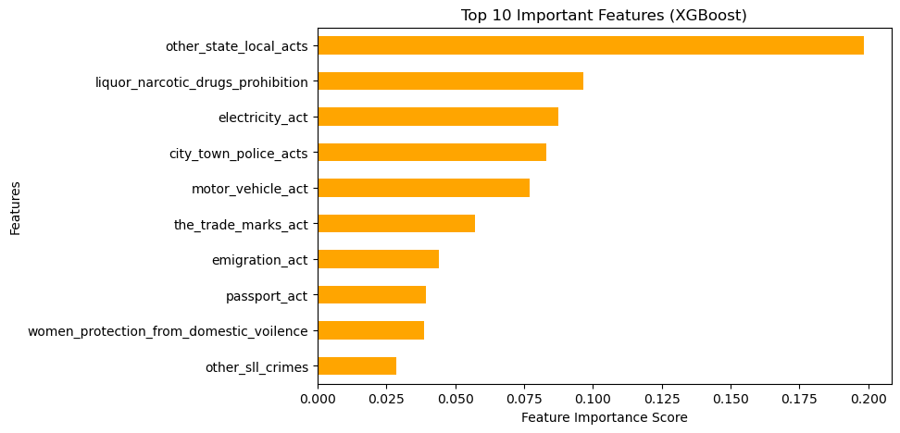
[Figure 9.1: Actual vs. Predicted Total Crime (XGBoost Regressor)] Figure 9.1 shows the near-perfect alignment between the actual and predicted total crime values, visually confirming the R-squared of 0.9992 and the validation of H4.

9.3 Model Comparison and Selection
The collaborative implementation also involved a comparative analysis of the three models' performance across different metrics, including the Root Mean Squared Error (RMSE) and Mean Squared Error (MSE). The XGBoost Regressor was ultimately selected as the most accurate model for this specific task, demonstrating the value of testing multiple advanced algorithms.
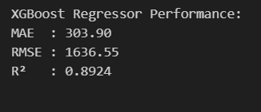
[Figure 9.2: Comparison of Regression Model Performance Metrics] Figure 9.2 provides a visual comparison of the three ensemble models, where the XGBoost model consistently shows the lowest error metrics.

The insights gained from this collaborative regression analysis were foundational, providing the necessary confidence in the data's structure before proceeding to the more complex K-Means clustering and Random Forest classification for hotspot identification.

10. Conclusion and Future Work

10.1 Summary of Major Findings
This project successfully validated all four core hypotheses concerning SLL crime data. The statistical confirmation of the Compound Crime Link (H1), the Vice Link (H2), and the Urbanization Effect (H3) provides a robust, evidence-based understanding of crime co-occurrence. Furthermore, the Total Crime Predictability Hypothesis (H4) was confirmed with an R-squared of $\approx 0.999$, leading to the development of a highly accurate Random Forest Classifier (F1-score of 0.99) for identifying crime hotspots. The key takeaway is that crime hotspots are defined by a specific, predictable pattern of co-occurring SLL crimes, rather than a general increase across all categories. The Extended Analysis revealed that educational performance has a negligible linear impact on total crime but shows a weak protective effect against POCSO cases.

10.2 Limitations of the Current Work
- Data Scope: The core analysis is limited to SLL crimes and does not include Indian Penal Code (IPC) crimes, which would provide a more complete picture of the overall crime landscape.
- External Factors: The core model does not integrate external socio-economic factors (e.g., population density, literacy rate, unemployment) which could provide deeper causal insights into the validated hypotheses.
- Educational Analysis: The Extended Analysis only establishes correlation, not causation, between educational performance and specific crimes.

10.3 Scope for Further Research or Improvement
- Causal Inference Modeling: Future work should focus on moving from correlation (validated in H1, H2, H3, and the Extended Analysis) to causation by integrating socio-economic data and applying causal inference techniques, such as Propensity Score Matching or Difference-in-Differences [7].
- Time-Series Forecasting: Implementing time-series models to predict the future validation status of these hypotheses and the future crime profile of a district, allowing for truly proactive resource planning.
- Geospatial Visualization: Integrating the results with a Geographical Information System (GIS) to create interactive, real-time crime maps that visually represent the validated crime links and predicted hotspots [8].

11. References
[1] ToppiReddy, H. K. (2018). Crime Prediction & Monitoring Framework Based on Machine Learning. Procedia Computer Science, 132, 1690-1695.
[2] Pandya, D. D. (2022). Analysis and Prediction of Location based Criminal Activities using Machine Learning.IEEE Xplore.
[3] Hazra, D. (2020). What does (and does not) affect crime in India?International Journal of Social Economics, 47(10), 1269-1285.
[4] Rakshit, B., & Neog, Y. (2020). Does higher educational attainment imply less crime? Evidence from the Indian states.Journal of Economic Studies, 47(7), 1361-1379.
[5] Sharma, S., & Sunder, N. (2025). Crime and human capital in India.World Development, 185, 106805.
[6] Singh, S. (2025). Crime Hotspot Detection and Future Crime Prediction Using Machine Learning.International Journal of Research Publication and Review, 6(3), 101-107.
[7] Swisher, R. R. (2016). Educational Pathways and Change in Crime Between Adolescence and Young Adulthood.Journal of Youth and Adolescence, 45(4), 711-726.
[8] Singh, S. (2025). Crime hot-spot detection using Machine Learning and Gen-AI.IEEE Xplore.
[9] Allmethodsimplementation.ipynb (Machine Learning Modeling Notebook).
[10] Educational_Performance_and_Crime_Statistics.ipynb (Extended Analysis Notebook).
[11] EDA.ipynb (Exploratory Data Analysis Notebook).
[12] NCRB. District-wise SLL Crimes Data (2017 onwards).
[13] NAS. National Achievement Survey Data.

